**NAME :** CAROLINE NYAMBURA WACHIRA

**EMAIL**:Caroline.nyambura@womentechsters.org

**DATE OF SUBMISSION**: 10TH JULY 2021

**PRACTICAL ACTIVITY FOR WEEK 6**

**QUESTION 1**

Is your browser running HTTP version 1.0 or 1.1? What version of HTTP is the server running? **Yes, it is actually running o HTTP VERSION 1.1 please find the attached screen short below in row /column 6 as highlighted.**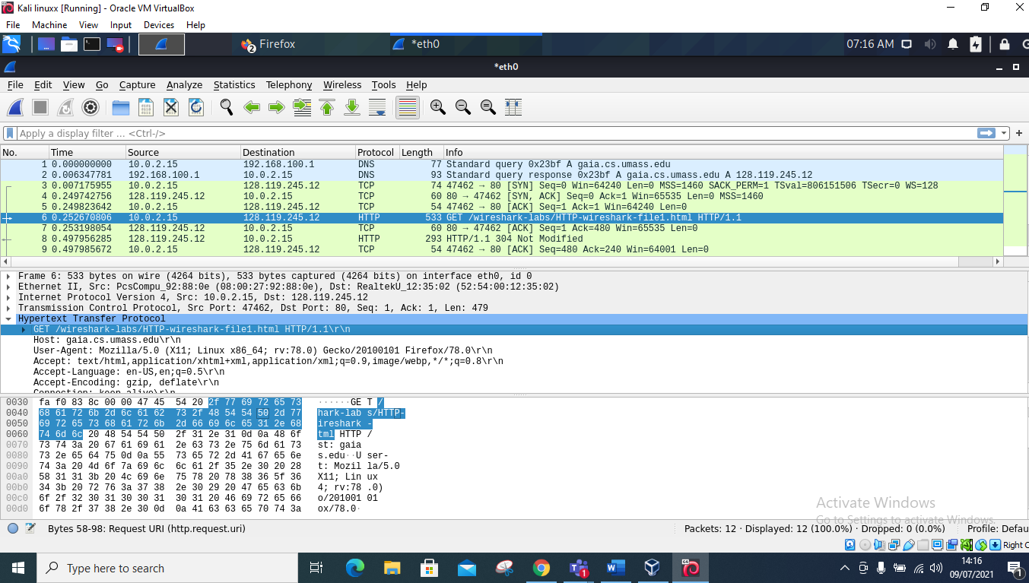

**QUESTION 2**

What languages (if any) does your browser indicate that it can accept to the server? In the captured session, what other information (if any) does the browser provide the server with regarding the user/browser?

**ANSWER**

**The languages it accepts is:en- US,en; q=0.5,\r\n .**

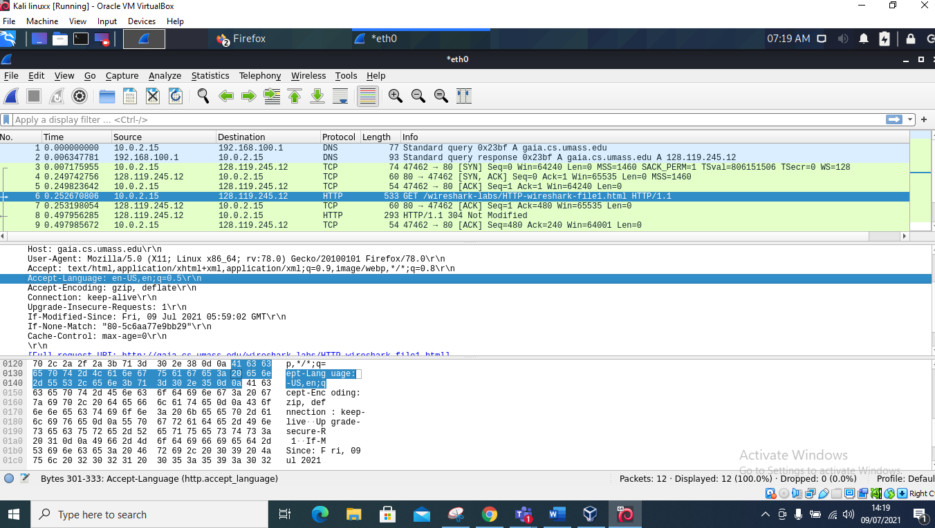

**QUESTION 3**

What is the IP address of your computer? Of the gaia.cs.umass.edu server?

**ANSWER**

**The IP address of my computer is 128.119.245.12. found in column 6 find attached screen short.**

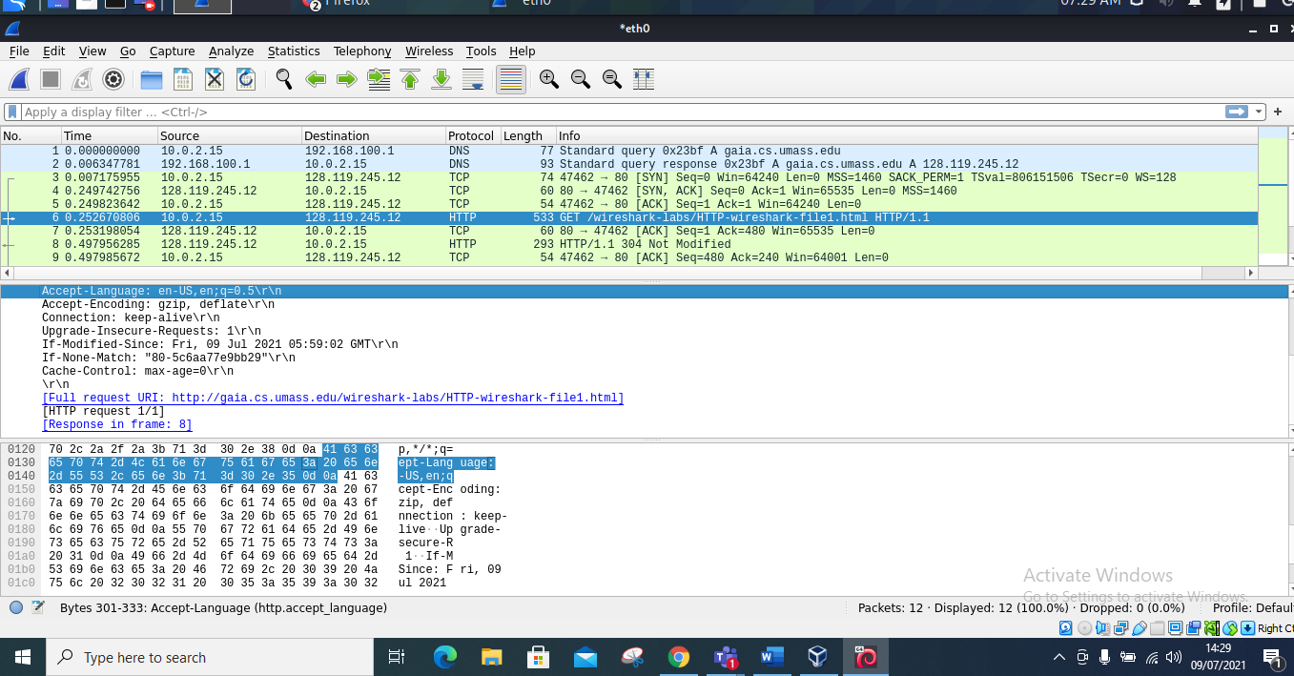

**QUESTION 4**

What is the status code returned from the server to your browser?

**ANSWER**

**The code returned is: zip, deflate\r\n**

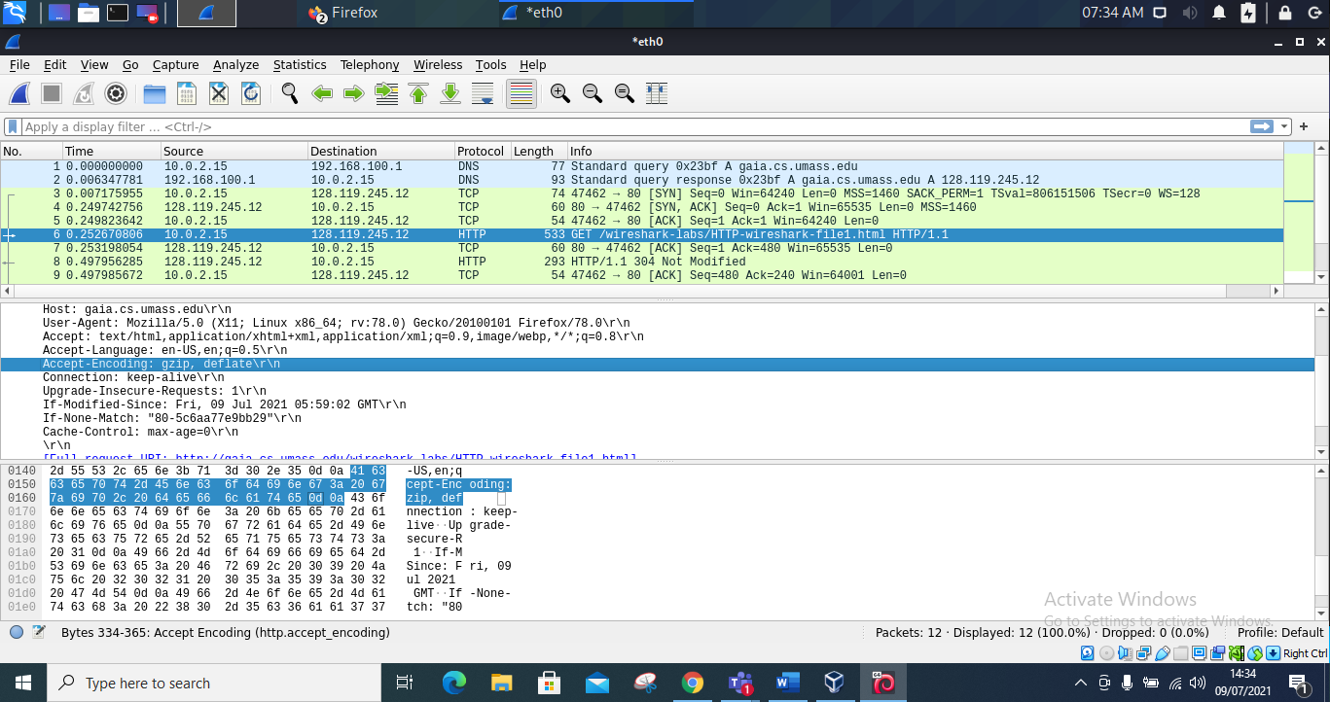

**QUESTION 5**

When was the HTML file that you are retrieving last modified at the server?

**ANSWER**

**The HTML file was last modified on Friday,09 July 2021. at Time: 05:59:02 Gmt\r\n. Find the attached screen short below.**

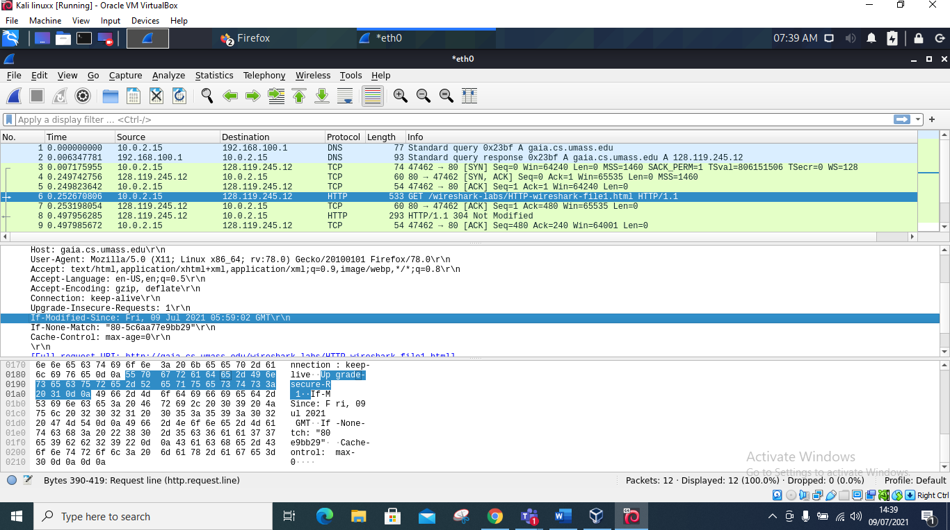

**QUESTION 6**

How many bytes of content are being returned to your browser?

**ANSWER**

**In other words, bytes of content also mean the length hence in column/row six that’s where you see the bytes which is 533 bytes**

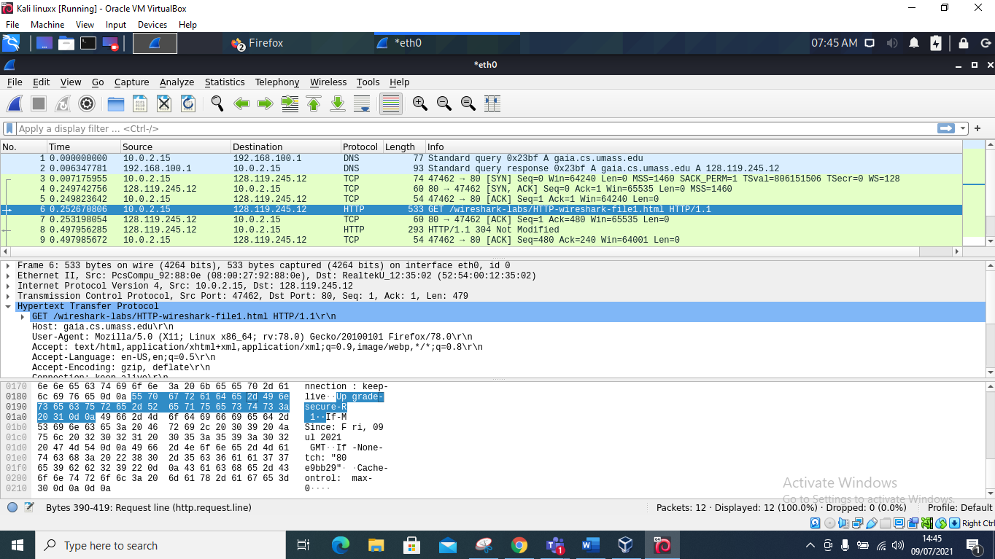

**Question 7**

By inspecting the raw data in the packet content pane, do you see any http headers within the data that are not displayed in the packet-listing window? If so, name one.

**ANSWER**

**Yes, I can see other http headers that are not displayed in the packet list they include: number row /column 8, a HTTP that has a length of /bytes of 293 and its information is not modified hence its Ip address is 10.0.2.15**

